

MIDDLE EAST TECHNICAL UNIVERSITY

ELECTRICAL-ELECTRONICS ENGINEERING DEPARTMENT

EE463 HW3- Duty Controlled Full Bridge Isolating Converter Design

PREPARED BY
HÜSEYİN OĞUZ-2516623
KERİM ÇAĞRI ŞEN-

Homework 3

Duty Controlled Full Bridge Isolating Converter Design

Introduction

The homework problem involves the overall design and simulation of a 250-W duty-controlled full bridge isolating converter. The homework problem includes the entire engineering process, from the analytical design of the circuit parameters such as the turns ratios and filters to satisfy particular ripple specifications. A major part of the homework problem involves magnetic designs, including the choice of cores and wires for maximizing efficiency and reducing losses in both the transformer and the inductor. The final step involves validating the designs through simulation and thermal analysis of the commercial semiconductor devices to verify the satisfaction of rated operating conditions.

Experimental Results

Q1)

a)

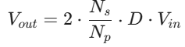

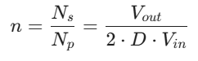

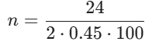

n= 4/15

b)

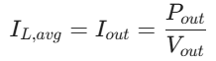

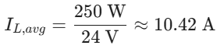

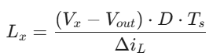

V_{x}=V_{sec}=n.V_{in}=0.2667*100= 26.67 V

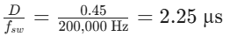

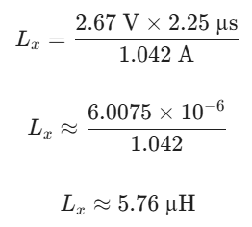

The required inductance value to have an inductor ripple 10% of the average inductor current value is calculated as 5.76 mu H.

c)
When the switch is on, V_{L}= V_{in}*(N_{s}/N_{p})-V_{out}, so inductor current rises:
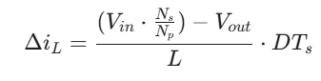
The capacitor current is the AC part of the inductor current (i_{c}(t)=i_{L}(t)-I_{out}).
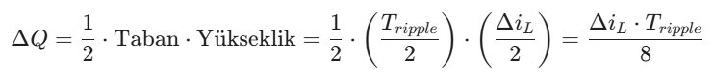
Where f_{ripple}= 2*f_{sw}, Tripple= 1/(2*f_{sw}).
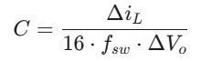

Δi_{L}=1.042 A

fsw=200 kHz

V_{out}=24 V

ΔV_{o}= %1 of V_{out}= 0.24 V

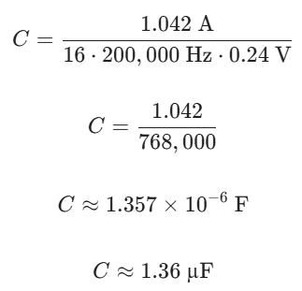

Q2)

a)

b)

c)

d)
e)

f)

Q3)

a)

b)

c)

d)

Conclusion

